Twilio Step

Objective

Twilio’s APIs power its platform for communications. Behind these APIs is a software layer connecting and optimizing communications networks around the world to allow your users to call and message anyone, globally.

Using Twilio's REST API, you can send outgoing SMS messages from your Twilio phone number to mobile phones around the globe.

UI

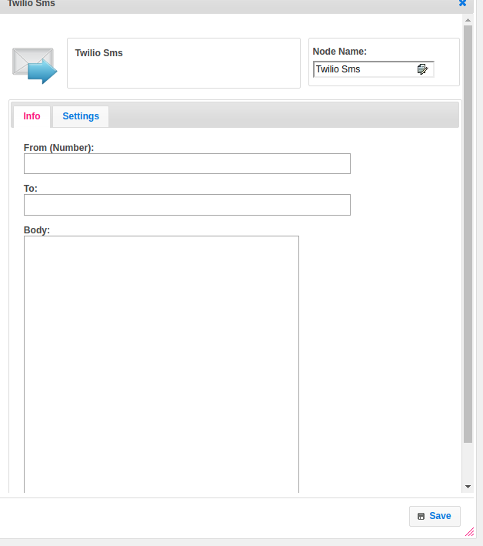

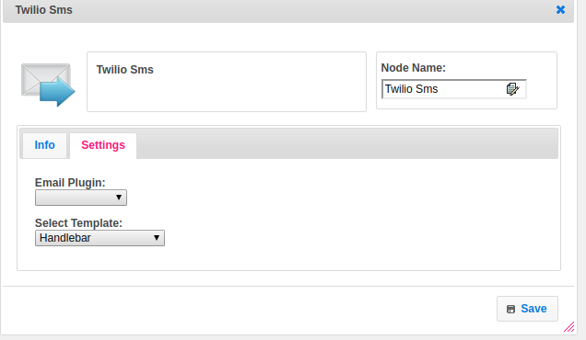

## Attributes

|  |  |
| --- | --- |
| **Attributes** | **Description** |
| **1. From (number)** | From specifies the Twilio phone number, [short code,](https://www.twilio.com/docs/glossary/what-is-a-short-code) or Messaging Service that sends this message. This must be a Twilio phone number that you own, formatted with a '+' and country code, e.g. +16175551212 ([E.164](https://www.twilio.com/docs/glossary/what-e164) format). You can also use a Messaging Service SID.  To get your first Twilio phone number, [head on over to the console](https://www.twilio.com/console/phone-numbers/search) and find a number you like with SMS capabilities. If you're interested in using a shortcode, you can [apply for one via the console](https://www.twilio.com/console/sms/short-codes) as well. |
| **2. To** | Recipent Phone number. |
| **3. Body** | IThe Body parameter includes the full text of the message you want to send, limited to 1600 characters. |
| **4. Email Plugin** | Name of the plugin, which contains configuration information regarding Twilio. |
| **5. Select Template** | Select Template used to set the value type.  Value types are two types.  1.hb-HandleBars  2.ftl-Freemarker Template Language. |

## 

## Executor Description

In Twilio executor class checks from-number, to-number, and body is empty or not.Call the sendMessage method by passing from-number, to-number, and body as parameters. In to-number array contains more than one number then the numbers can split by using “;”.Call the creator method of Message class provided by Twilio rest API by passing the to-number, from-number, and body.

## Plugin Dependency:

|  |  |
| --- | --- |
| **Attributes** | **Description** |
| **1. Plugin Config Name** | Name of the plugin |
| **2. Account SID** | An application SID is a way that a Twilio application is identified. An application is a container for a set of URLs and configurations that you can use for a phone number or a group of phone numbers. Using applications instead of individual URLs makes it easier to update all of your phone number configurations at one time in the case that your application moves. You can specify an application for Voice, SMS or for both.  You can create and manage application SIDs from your [Twilio Console.](https://www.twilio.com/console/voice/dev-tools/twiml-apps)  For more information on applications, see our [applications documentation](https://www.twilio.com/docs/api/rest/applications). |
| **3. Auth Token** | Twilio uses two credentials to determine which project an API request is coming from: The Account SID, which acts as a username, and the Auth Token which acts as a password.  If another user gets access to your Auth Token, and he or she knows your Account SID, they will have the ability to use the Twilio API as if they were you. That means they can make calls or send messages coming from your phone numbers, download your logs, and [change the URL settings](http://www.twilio.com/docs/api/rest/incoming-phone-numbers) of your Twilio phone numbers. Keep your Auth Token private, and if you share your code publicly make sure to remove your Auth Token. |

## Resource:

Please find the below link to get more information.

<https://www.twilio.com/docs/sms/send-messages>